Water quality section of sustainability paper

# Methods: Jeff (Note: Jeff drafted some text but not included here.)

## Water quality sustainability metric

The water quality sustainability metric that was selected is based on nutrient losses, because of the importance of nutrients in nitrate-N and total phosphorus loads in national water quality issues. There have been a large number of people who have been debating reductions for at least a decade and a consensus has formed on what the goals should be. So rather than coming up with new values, we will adopt what the group has already done. A large body of work exists that forms a good basis.

Loads on a per area basis are the only metric that makes sense for individual fields in corn-based systems. Proposed numeric water quality criteria are based on concentration, but concentration standards would not allow the sustainability assessment of fields.

Why 3 states? Of the Midwest, they are the ones that have plans in place. Using what is available. They provide the full range; would likely fall in between. (For discussion: Could say that these are really far apart so other states likely in between) (Could look at other hypoxia work (SPARROW) and see where they fall - Laura.)

Focus of this paper is Corn Belt states that drain to the Gulf of Mexico. They have the 45% reduction goal

## Determining the numeric goal

Subtract point sources; Denominators (as previously written.) (I realize that Matt and I may need to write this up.)

## Data from drained corn-based cropping systems

•         CSCAP

o   Explain database (done in other sections of this paper)

o   We are including free drainage and controlled drainage sites

o   Explain sites, fact that we combine all plots with one treatment into one “site” for this.

•         MANAGE

o   Explain database (citations)

* Only included “Corn Belt” states that have parts draining to Gulf because of our definition of sustainability (45% reduction)
* Used free drainage with no inlets to look at conventional systems

Do we want to use something like this that Gio provided to show amount of data in the two databases? I’m not sure it is needed (just shows how many plots per site) but may add weight to the results. But I would suggest just giving numbers

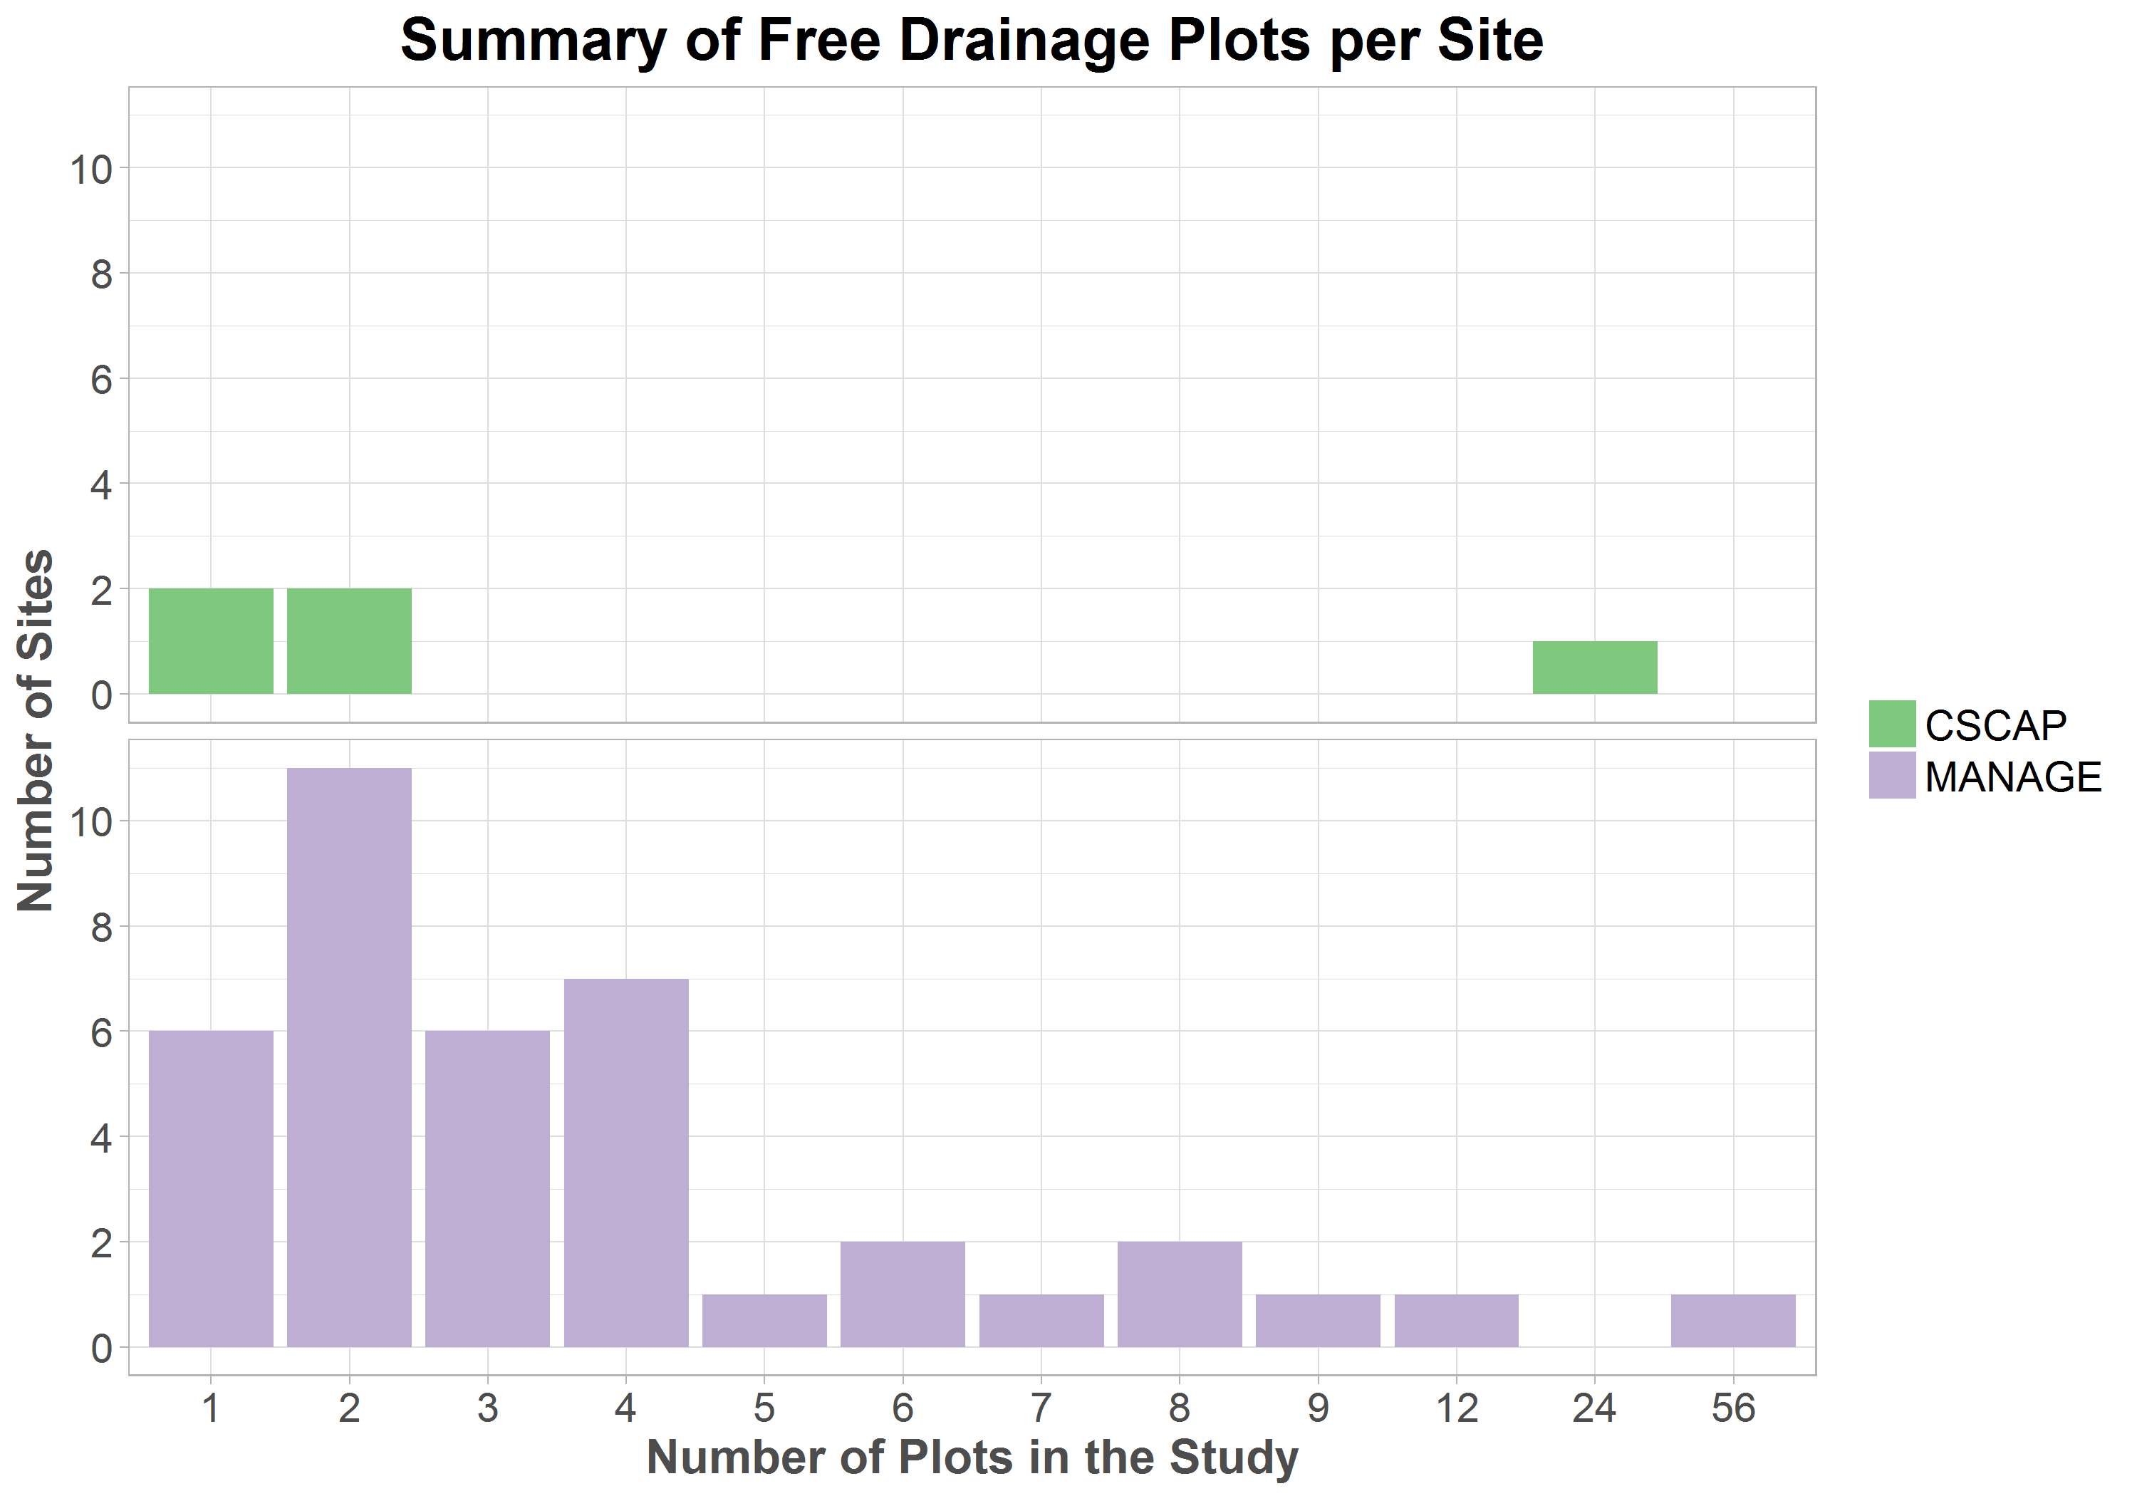

## Comparison to sustainable systems

•    Explain the cumulative probability method or any other way we make the comparison (this section may not be needed; maybe just in Results).

•   Second question was, if existing system will not meet the goal (is not sustainable), what if we implemented various practices? Cover crops, controlled drainage. Our questions is “Can water quality loads be made sustainable within the cropped field?” so we will focus on in-field practices. If goal cannot be met with these, then need to look at edge-of-field practices, but they are not reviewed here.

# Results (Jane and Laura)

## Water quality sustainability metrics

The water quality sustainability metrics, in the form of nitrate-N and phosphorus loads for corn-based cropping systems, differ among the three states (Table 1). This might be due to … (I still haven’t checked with people who calculated in Minnesota and Illinois whether they agree with the way I calculated, so these are not too certain. )(But once results are finalized, what else can we say about these values? Laura, is this where we would include USGS load estimates?

|  |  |  |
| --- | --- | --- |
| State | Sustainable Nitrate-N Load (kg/ha) | Sustainable Phosphorus Load (kg/ha) |
| Illinois | 8.0 | 0.48 |
| Iowa | 17.1 | 0.69 |
| Minnesota | 6.6 | 0.32 |

## Comparison of drained fields to water quality sustainability metrics

The nitrate-N load cumulative frequency curves for the CSCAP and MANAGE databases both show that nitrate-N and phosphorus loads from drained corn-based cropping systems usually exceeds these sustainability metrics (Figure 1). The smoother curve for the MANAGE database is due to the larger number of site years. There are 180 in the MANAGE database from 39 sites, while there are 23 in the CSCAP database from 5 sites. The median load (50% probability) for the CSCAP database is 32 kg/ha which is higher than the median of 26 kg/ha in the MANAGE database, although at higher loads the position of the two curves is reversed. There are 11 site years greater than 60 kg/ha in the MANAGE database [which were due to some unusual circumstance?]

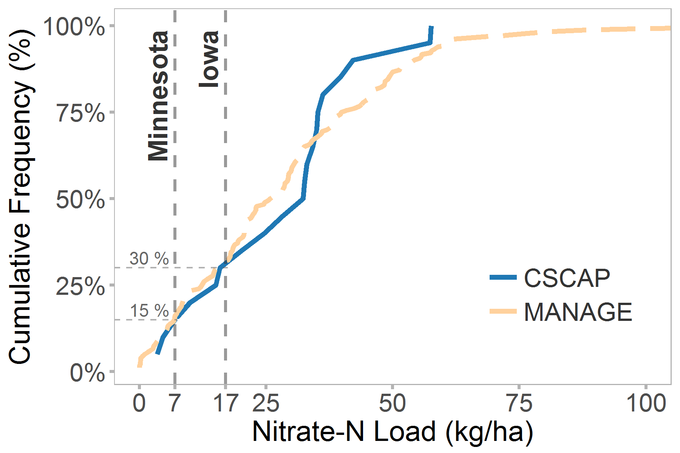

For discussion – does this have the right elements? Need a similar one for phosphorus. For discussion:

1. Y Axis label: Cumulative frequency? Percent less than?
2. Do we need to plot all the way to the highest load value (~120)? (If we do we might discuss it, as I propose above.)
3. I suggest adding markers, in part to give an idea of number of site years in each database; also that would distinguish from Figure 3 in the next section.

Figure 1: Cumulative frequency of nitrate-N loads for all site years, with three sustainability metrics

Just 15% of site-years in both the CSCAP and MANAGE databases had nitrate-N losses less than the Minnesota sustainability metric, while 30% of site-years were less than the Iowa metric.

The fact that only 15% of site years in these two databases did ~~not~~ meet the sustainability targets does not necessarily represent the percentage of all fields in the region that meet those targets. However the measured sites used normal agricultural practices (reference(s) for this?). There is no reason to assume that this sample is biased high or low.

Weather plays an important role in determining nitrate-N losses in any single year (Figure 2). Almost all sites (xx%) would have met the sustainability targets in 2012, when precipitation was low across the entire Corn Belt. However, in 2015, a moderately wet year, only __% would have met the Iowa target and __% would have met the Minnesota target.

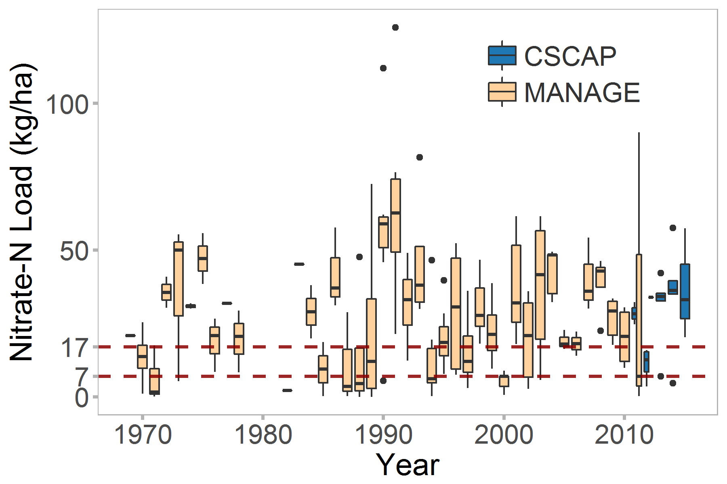

Figure 2: Distribution of nitrate-N loads in the CSCAP and MANAGE databases by year

## Potential for meeting sustainability targets with changes in agricultural practices

Adequate data for comparing the distribution were available for only one practice: controlled drainage. The cumulative frequency of monitored site years for controlled drainage is to the left of those for free drainage (Figure 3), meaning that loads are lower at all points in the distribution.

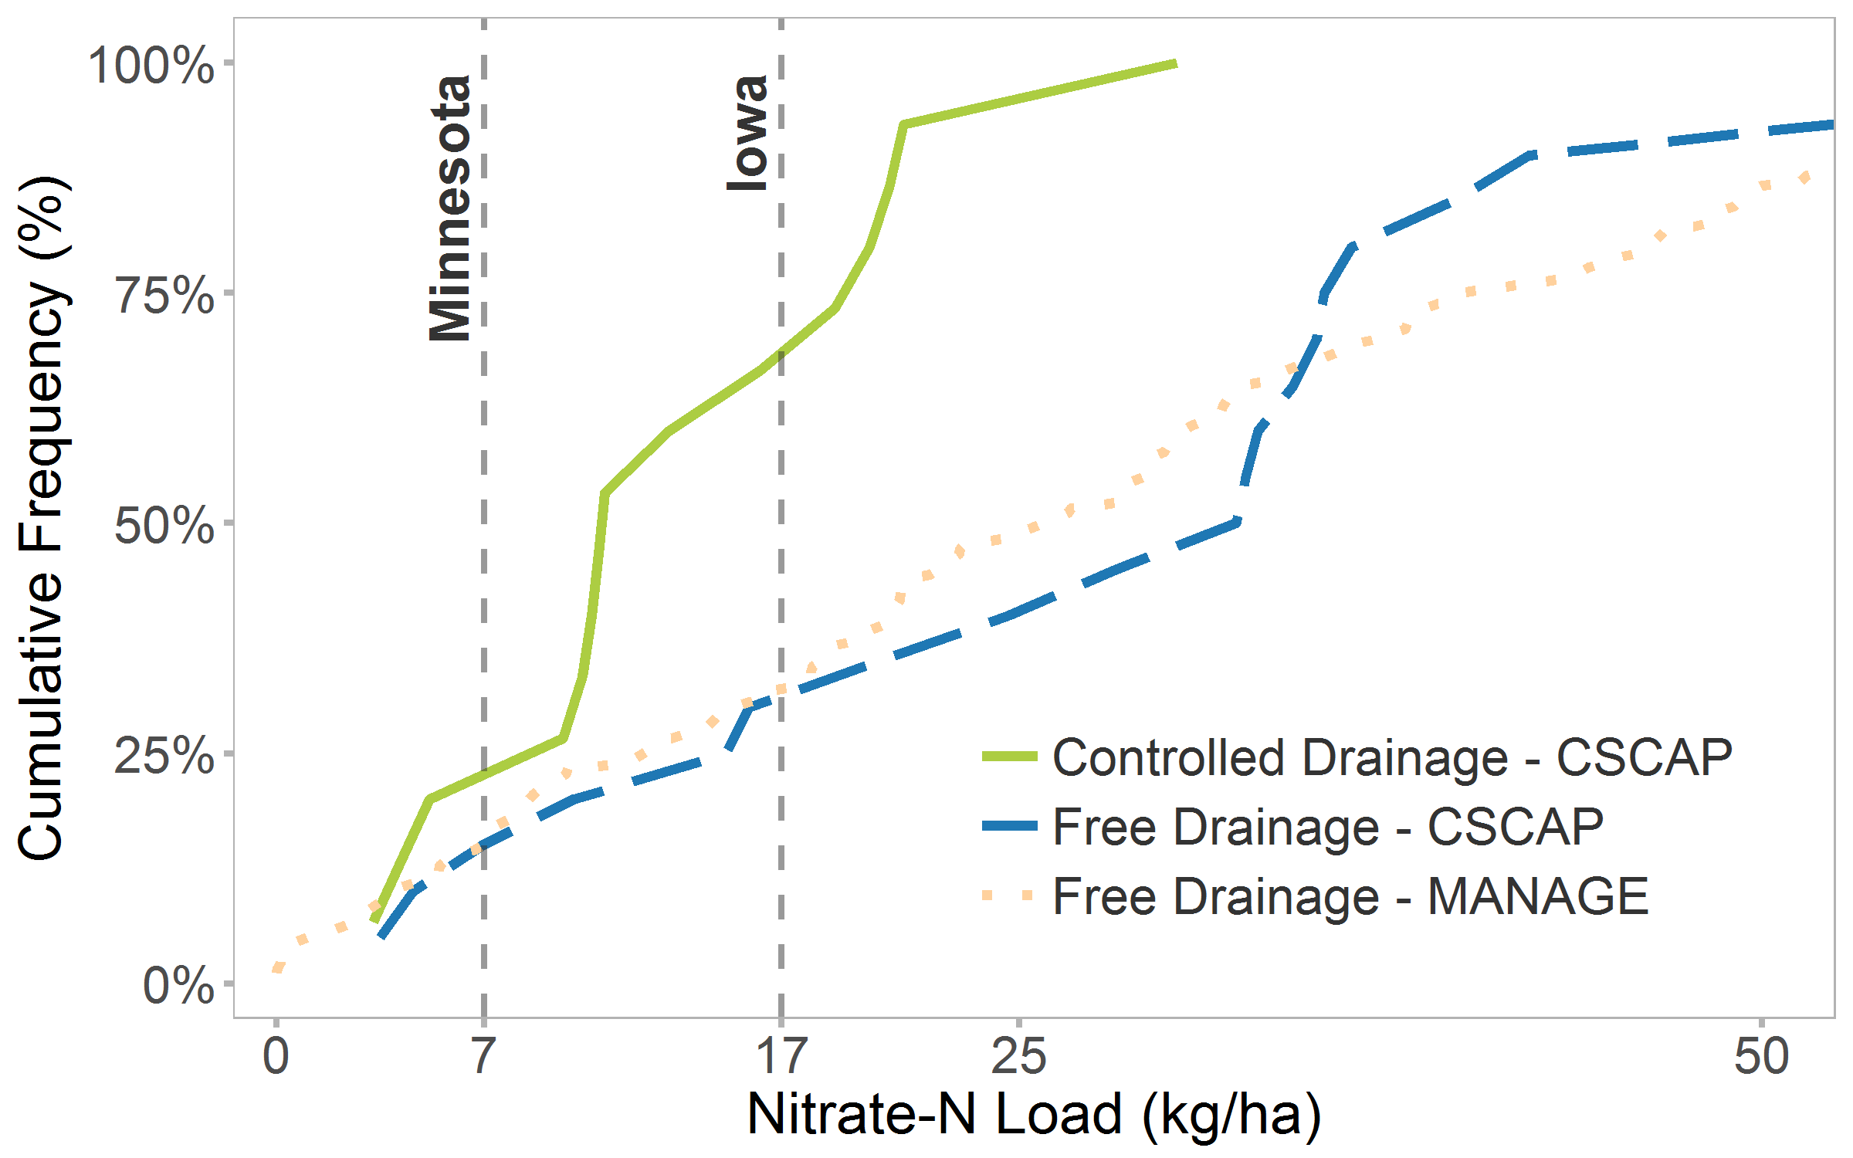

Figure 3: Potential reduction in nitrate-N losses with controlled drainage

Other practices have been evaluated for their potential to reduce nitrate and phosphorus in the nutrient reduction strategies. These have generally used studies in locations adjacent to the states where used, and the distribution represents the site years included in those studies. (Do we need to give a reason we can’t plot those like above. Too few site years? Too limited areas?)

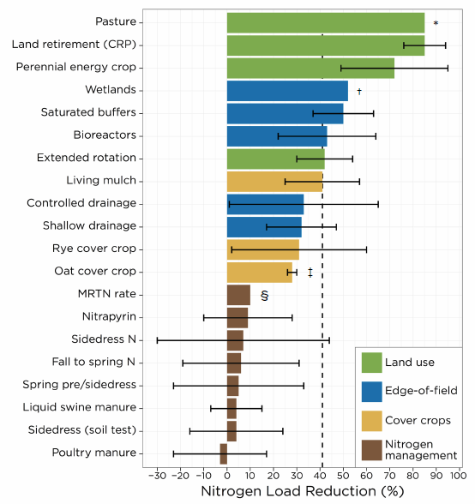

Figure 4: Potential reductions from other practices. [Maybe replot horizontally?, or do we need to include all the states?

Here is the comparison of all the practice reduction percentages, from Reid Christianson’s comparison ( http://owl.cwp.org/mdocs-posts/upper-mississippi-nutrient-loss-reduction-strategies/) Should we somehow graph that? **For Discussion**.

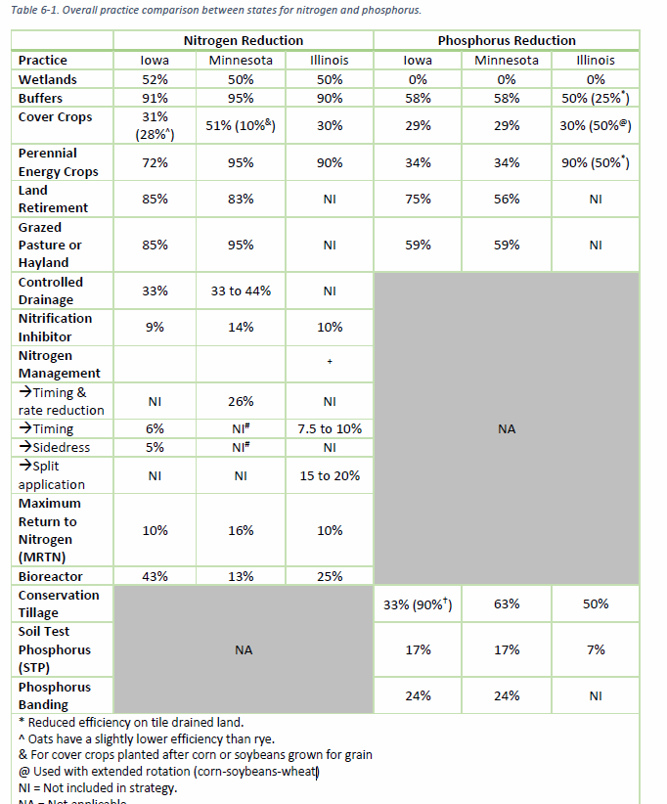

## Limitations and Discussion

Data included in this section were not collected with the purpose of this comparison, and thus statistically issues are unavoidable. However these data represent a wider sample of sites than have previously been presented together, and thus the benefits of the comparison were considered to override the limitations. Nevertheless, the following limitations should be kept in mind:

* The CSCAP sites all collected data from 2011 to 2015. Sites in the MANAGE database collected data over a wide variety of years (from 1969 to 2012) and thus differences include the differences in years.
* The CSCAP sites were part of one project, and an effort was made to collect comparable data (Kladivko et al., 2014). Even so, differences remain in methodology, potentially limiting the quality of comparisons. Sites in the MANAGE database differ even more. (Do they have a statement about limitations? Maybe something from paper.)
* Any others?

Data used in this section show that under current conventional management, corn-based systems in drained area are not sustainable from a water quality standpoint. . If we implement practices they have the potential to meet sustainability targets, although the level of changes will need to be high.

An overriding problem in estimating water quality impacts and sustainability is the lack of knowledge of the extent of drainage, which has an extremely high impact on nutrient losses. The ARMS corn survey in 2016 for the first time asked detailed questions about drainage including controlled drainage, in a well-design sample. These data will be available in 2018 and may be able to greatly expand our knowledge about .

## References

Kladivko, E.J., Helmers, M.J., Abendroth, L.J., Herzmann, D., Lal, R., Castellano, M.J., Mueller, D.S., Sawyer, J.E., Anex, R.P., Arritt, R.W. and Basso, B., 2014. Standardized research protocols enable transdisciplinary research of climate variation impacts in corn production systems. *Journal of Soil and Water Conservation*, *69*(6), pp.532-542.